**Exception Handling in Java**

The **exception handling in java** is one of the powerful *mechanism to handle the runtime errors* so that normal flow of the application can be maintained.

In this page, we will learn about java exception, its type and the difference between checked and unchecked exceptions.

**Advantage of Exception Handling**

The core advantage of exception handling is **to maintain the normal flow of the application**. Exception normally disrupts the normal flow of the application that is why we use exception handling. Let's take a scenario:

1. statement 1;
2. statement 2;
3. statement 3;
4. statement 4;
5. statement 5;//exception occurs
6. statement 6;
7. statement 7;
8. statement 8;
9. statement 9;
10. statement 10;

Suppose there is 10 statements in your program and there occurs an exception at statement 5, rest of the code will not be executed i.e. statement 6 to 10 will not run. If we perform exception handling, rest of the statement will be executed. That is why we use exception handling in java.

Do You Know ?

|  |
| --- |
| * What is the difference between checked and unchecked exceptions ? * What happens behind the code int data=50/0; ? * Why use multiple catch block ? * Is there any possibility when finally block is not executed ? * What is exception propagation ? * What is the difference between throw and throws keyword ? * What are the 4 rules for using exception handling with method overriding ? |

**Hierarchy of Java Exception classes**

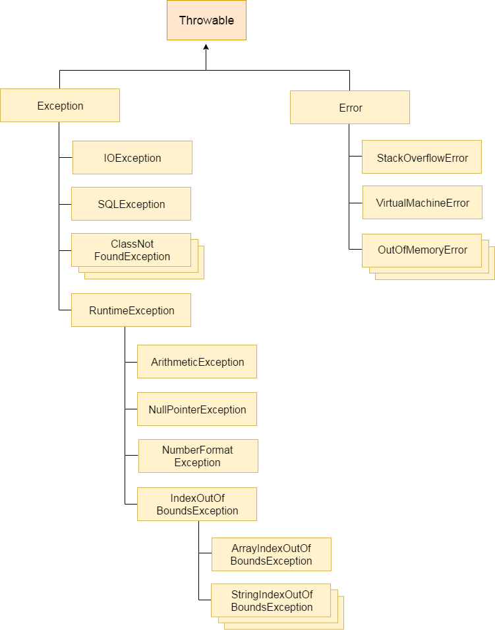

**Types of Exception**

There are mainly two types of exceptions: checked and unchecked where error is considered as unchecked exception. The sun microsystem says there are three types of exceptions:

1. Checked Exception
2. Unchecked Exception
3. Error

**Difference between checked and unchecked exceptions**

1) Checked Exception

The classes that extend Throwable class except RuntimeException and Error are known as checked exceptions e.g.IOException, SQLException etc. Checked exceptions are checked at compile-time.

2) Unchecked Exception

The classes that extend RuntimeException are known as unchecked exceptions e.g. ArithmeticException, NullPointerException, ArrayIndexOutOfBoundsException etc. Unchecked exceptions are not checked at compile-time rather they are checked at runtime.

3) Error

Error is irrecoverable e.g. OutOfMemoryError, VirtualMachineError, AssertionError etc.